#### Stacks Primitive Operations:

A stack is a data structure of elements that are inserted and removed according to the last-in first-out (LIFO) principle. In the pushdown stacks only two operations are allowed: push the item into the stack, and pop the item out of the stack. A stack is a limited access data structure - elements can be added and removed from the stack only at the top. Push adds an item to the top of the stack, pop removes the item from the top. A helpful analogy is to think of a stack of books; you can remove only the top book, also you can add a new book on the top.

A stack may be implemented to have a bounded capacity. If the stack is full and does not contain enough space to accept an entity to be pushed, the stack is then considered to be in an overflow state. The pop operation removes an item from the top of the stack. A pop either reveals previously concealed items or results in an empty stack, but, if the stack is empty, it goes into underflow state, which means no items are present in stack to be removed.

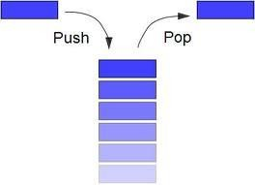

#### Stack (ADT) Data Structure:

Stack is an Abstract data structure (ADT) works on the principle Last In First Out (LIFO). The last element add to the stack is the first element to be delete. Insertion and deletion can be takes place at one end called TOP. It looks like one side closed tube.

* + The add operation of the stack is called push operation
  + The delete operation is called as pop operation.
  + Push operation on a full stack causes stack overflow.
  + Pop operation on an empty stack causes stack underflow.
  + SP is a pointer, which is used to access the top element of the stack.
  + If you push elements that are added at the top of the stack;
  + In the same way when we pop the elements, the element at the top of the stack is deleted.

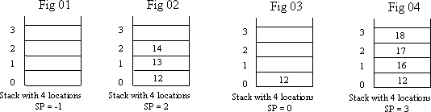

#### Operations of stack:

There are two operations applied on stack they are

1. push
2. pop.

While performing push & pop operations the following test must be conducted on the stack.

1. Stack is empty or not
2. Stack is full or not

#### Push:

Push operation is used to add new elements in to the stack. At the time of addition first check the stack is full or not. If the stack is full it generates an error message "stack overflow".

#### Pop:

Pop operation is used to delete elements from the stack. At the time of deletion first check the stack is empty or not. If the stack is empty it generates an error message "stack underflow".

#### Representation of a Stack using Arrays:

Let us consider a stack with 6 elements capacity. This is called as the size of the stack. The number of elements to be added should not exceed the maximum size of the stack. If we attempt to add new element beyond the maximum size, we will encounter a stack overflow condition. Similarly, you cannot remove elements beyond the base of the stack. If such is the case, we will reach a stack underflow condition.

When a element is added to a stack, the operation is performed by push().

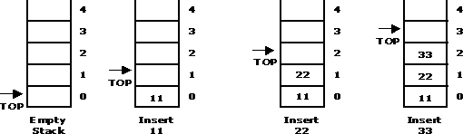

When an element is taken off from the stack, the operation is performed by pop().

